**3D Reconstruction Basic Terminology (Traditional Computer Vision Approach)**

[[VK](https://medium.com/@VK_Venkatkumar?source=post_page-----e148496f389--------------------------------)](https://medium.com/@VK_Venkatkumar?source=post_page-----e148496f389--------------------------------)

[VK](https://medium.com/@VK_Venkatkumar?source=post_page-----e148496f389--------------------------------)

·

[Follow](https://medium.com/m/signin?actionUrl=https%3A%2F%2Fmedium.com%2F_%2Fsubscribe%2Fuser%2F60f6508bffaf&operation=register&redirect=https%3A%2F%2Fmedium.com%2F%40VK_Venkatkumar%2F3d-reconstruction-basic-terminology-traditional-computer-vision-e148496f389&user=VK&userId=60f6508bffaf&source=post_page-60f6508bffaf----e148496f389---------------------post_header-----------)

6 min read

·

Jul 18, 2023

51

Computer vision is an interdisciplinary scientific field that deals with how computers can gain high-level understanding from digital images or videos.

**Main Goal of computer vision is to converting light into meaningful information (Geometrical, semantic etc…)**

**In this article, I talk about 3D computer vision basic terminology (Traditional Approaches).**

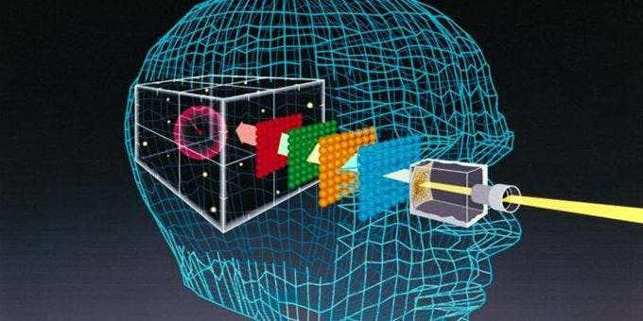

Credit: Online

Lets discuss about 3D computer vision terminology,

**WHAT ?**

3D computer vision is a field of computer science that focuses on the **analysis, interpretation, and understanding of three-dimensional visual data**. It involves the extraction of information about the three-dimensional structure, shape, and properties of objects or scenes from two-dimensional images or video.

**WHY?**

3D computer vision enables machines to go beyond 2D image processing and understand the three-dimensional structure of the world. It enhances perception, enables accurate depth estimation,object recognition and tracking, facilitates scene understanding, improves robotic capabilities, interaction with the physical world, and enables realistic representations in virtual and augmented reality. applications.

**WHERE?**

* **Depth perception:**By incorporating depth information, 3D computer vision allows machines to accurately perceive the distances and spatial relationships between objects. This is essential for tasks such as object recognition, scene understanding, and navigation in real-world environments.
* **Realistic representation:** 3D computer vision provides a more realistic representation of objects and scenes. This is valuable in applications like virtual reality, augmented reality, and computer graphics, where a faithful reproduction of the 3D world enhances the user experience and realism of virtual environments.
* **Improved object recognition and tracking:**By understanding the 3D structure of objects, 3D computer vision improves the accuracy and robustness of object recognition and tracking algorithms. It enables machines to recognize and track objects across different viewpoints, lighting conditions, and occlusions, leading to more reliable and precise results.

There are numerous applications, particularly in the medical area, the manufacturing business, and augmented and virtual reality etc…

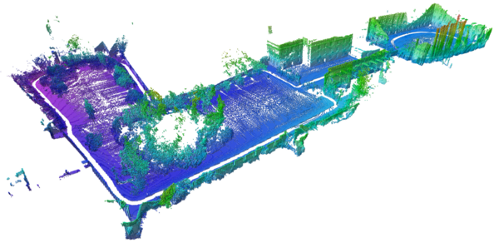

credit: Online

**We have begun to focus on the Terminology section**

1. **Camera Calibration:**

Camera calibration is the process of determining the camera’s internal characteristics (intrinsic parameters) and its position and orientation in camera’s space (extrinsic parameters), which are essential for accurate image analysis and 3D reconstruction in computer vision applications.

The **intrinsic parameters** describe the internal properties of the camera, including its focal length, principal point (the optical center of the image), lens distortion coefficients, and other factors that affect the image formation process. These parameters are typically fixed for a given camera and are crucial for accurately mapping image coordinates to real-world measurements.

The **extrinsic parameters** define the camera’s position and orientation in 3D space relative to a world coordinate system. They describe the camera’s translation (position) and rotation with respect to the world coordinate system. Estimating these parameters allows for mapping image points to corresponding 3D points in the world.

Camera calibration is an essential step in computer vision applications that involve accurate geometric analysis or 3D reconstruction. It ensures reliable and precise results by accounting for the camera’s intrinsic and extrinsic characteristics and enables consistent and accurate mapping between image measurements and the real world.

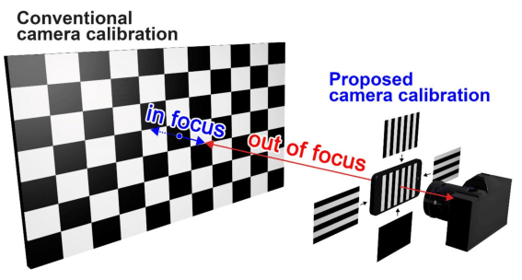

Credit: Online (Camera calibration mounting camera fit and calibrate the chess board)

If you want to more detail in camera calibration: [**link**](https://youtu.be/S-UHiFsn-GI)

**2. Feature Extraction:**

Feature extraction is a fundamental process in computer vision that involves identifying and extracting meaningful and distinctive information from images or data. Features are local patterns, structures, or characteristics that represent specific regions or objects within an image, and they serve as a basis for subsequent analysis and tasks such as object recognition, tracking, or image retrieval.

E.g., Edge, corner, boundary Identification etc.

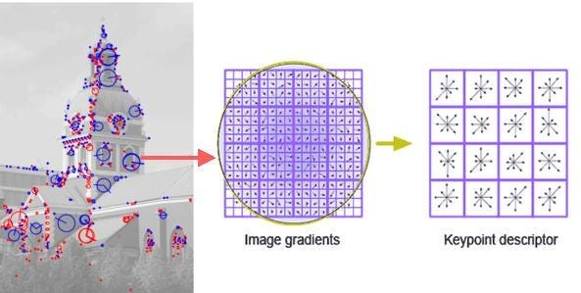

Template Matching (Credit: Online)

**3. Image Matching & Feature Matching:**

**Feature matching**, on the other hand, is a specific type of image matching that focuses on finding correspondences between local features or key points in different images. These local features capture distinctive and repeatable patterns or structures in the image, such as corners, edges, or blobs. Feature matching is particularly useful for tasks like object recognition, image alignment, tracking, and image retrieval.

**Image matching** and feature matching are closely related concepts in computer vision. Both involve finding correspondences between points or features in different images, but they differ in terms of their scope and purpose.

E.g., Template Matching, SIFT, SUFT etc..

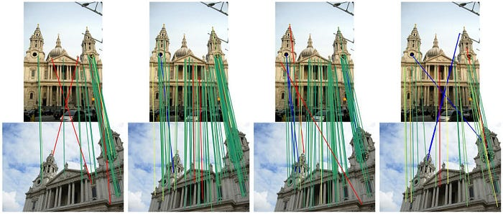

Image matching (credit: Online)

**4. Structure From motion:**

Structure from Motion (SfM) is a computer vision technique that aims to recover the 3D structure of a scene and estimate camera poses from a set of 2D images or video frames. It combines the principles of camera geometry, image feature extraction, and motion estimation to reconstruct the 3D geometry of the scene and the camera’s trajectory.

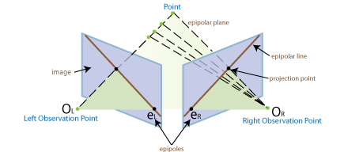

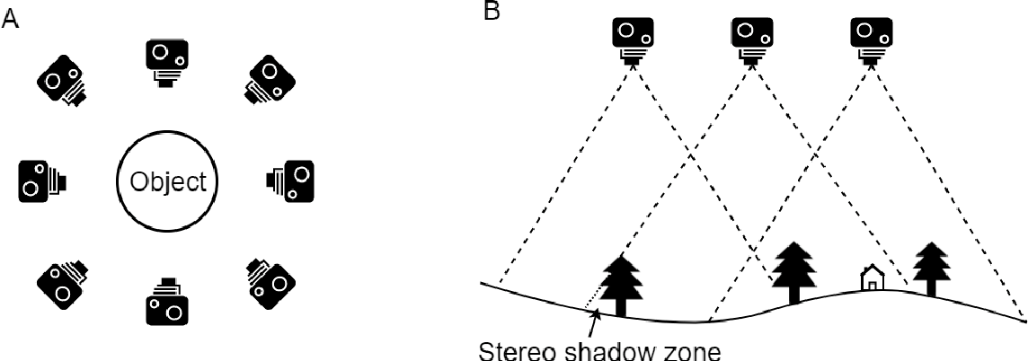

**5. Depth estimation:**

Estimate the depth or distance information for each pixel or feature point in the scene. This can be achieved using techniques such as stereo matching, structure from motion, or depth from focus. Depth estimation aims to recover the 3D structure of the scene, providing the distance of each point from the camera.

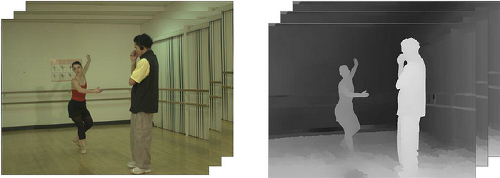

Credit: Online (Depth estimation of each frames)

**6. Point Cloud:**

A point cloud is a collection of 3D points that represent the surface or structure of an object or a scene. Each point in the point cloud is defined by its X, Y, and Z coordinates in a three-dimensional coordinate system. Point clouds are commonly used in computer vision and 3D reconstruction applications as a way to represent the geometric information of objects or scenes.

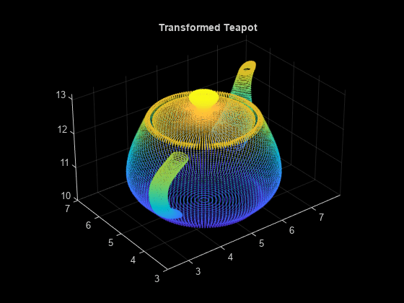

Credit: Online (Point Cloud)

**7. Dense reconstruction:**

Utilize the depth information and the correspondences between the images to reconstruct the 3D geometry of the scene densely. This process involves triangulating the matched points or pixels to obtain their 3D coordinates and creating a dense point cloud or surface representation of the scene.

**8. Surface refinement:**

Refine the dense reconstruction to improve its accuracy and smoothness. This can involve techniques such as surface regularization, noise filtering, or mesh optimization to obtain a visually pleasing and coherent representation of the scene’s surface.

**9. Meshing:**

A mesh is a representation of a three-dimensional object or surface composed of a collection of vertices, edges, and faces. It is a fundamental data structure used in computer graphics, computer-aided design (CAD), and 3D modeling.

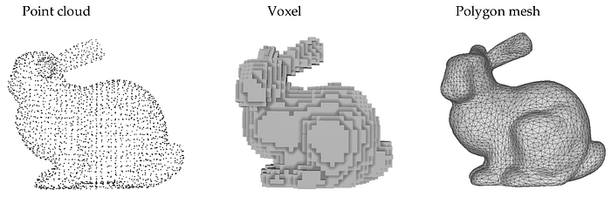

Mesh output (Credit: Online)

**10. Texturing:**

Texturing is the process of applying and mapping textures onto the surfaces of 3D objects or meshes. Textures are 2D images or patterns that can be wrapped around the surfaces of 3D models to provide them with color, detail, and visual realism. Texturing is an essential component of computer graphics, game development, virtual reality, and 3D modeling.

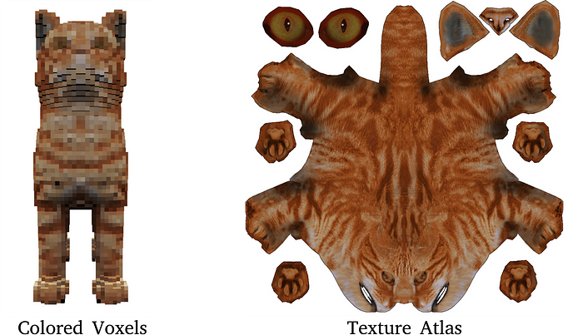

Texture (credit: Online)

**Camera calibration, in my opinion, is a critical stage in 3D reconstruction.**

These are the traditional computer vision 3d reconstruction steps.

3D reconstruction using deep learning approaches is becoming increasingly popular these days.

E.g., NERF, NERF PL, NEROIC etc…

**In the future, I intend to compose an in-depth post about each step of the traditional 3D computer vision reconstruction technique.**

I appreciate you coming, people. Please leave a comment if this article contains any questions or errors. or let’s connect via kaggle conversation or linkedin.

**Reference and credits:**

1. Computer vision (3D): [**link**](https://youtube.com/playlist?list=PL05umP7R6ij35L2MHGzis8AEHz7mg381_)
2. First principle of Computer vision: [link](https://www.coursera.org/specializations/firstprinciplesofcomputervision?)

***Social network :***[***linkedin***](https://www.linkedin.com/in/venkat-vk/)***,***[***Kaggle***](https://www.kaggle.com/venkatkumar001)***,***[***Github***](https://github.com/VK-Ant)

[Computer Vision](https://medium.com/tag/computer-vision?source=post_page-----e148496f389---------------computer_vision-----------------)

[3d Reconstruction](https://medium.com/tag/3d-reconstruction?source=post_page-----e148496f389---------------3d_reconstruction-----------------)

[Python](https://medium.com/tag/python?source=post_page-----e148496f389---------------python-----------------)

[AI](https://medium.com/tag/ai?source=post_page-----e148496f389---------------ai-----------------)

[3d](https://medium.com/tag/3d?source=post_page-----e148496f389---------------3d-----------------)